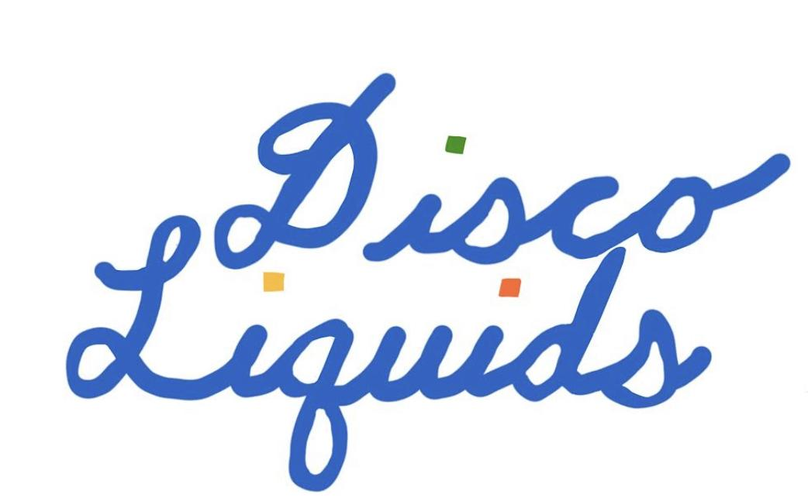

New Customer Info
Thank you for your interest in working with us!
By filling out this form, you agree to the following terms:

- Minimum order for delivery: 2 cases (24 bottles or equivalent) or $250
- We deliver to New Orleans twice a week, and to Baton Rouge and Lafayette once a week
- Minimum order for delivery outside of the New Orleans, Baton Rouge, or Lafayette metro areas: 4 cases or $500 with timing dependent on our schedule
- Per Louisiana State Law and because we are set up as a for-profit business, all payment will be due within 15 days of your receipt of your order. If you are unable to pay within the state-mandated time frame, we will be forced to report your delinquency to the ATC and all orders from that point on will be paid for in cash upon delivery until you’re no longer delinquent
- In order for next (delivery) day arrival, you must place orders by 4pm. We’re pretty flexible, but please do your best!

Business Name:
DBA (if different):
Business Address:
City: Zip:

Billing Address (if different):
City: Zip:

Hours of Operation:
Preferred Delivery Window (times and days of the week):
Business Phone Number:

Wine Buyer’s Name & Pronouns: Phone: Email: Preferred method of contact:

Accountant’s Name & Pronouns (if different):
Phone: Email:

Business Owner’s/Manager’s Name & Pronouns (if different):
Phone: Email:

Business FEIN:
Preferred Payment Method:
Check (made out to Disco Liquids, LLC) Online payment

Anything else we should know about you?

